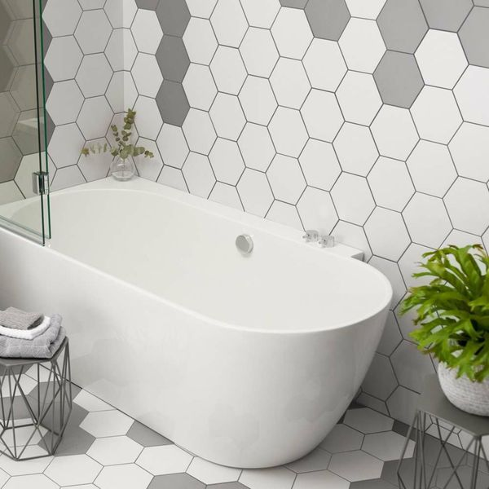**White Novel Hexagon Tiles:**

## **Product Description**

Freshen up an interior area with these stylish White Novel Hexagon Tiles. These hexagonal porcelain tiles are suitable for both walls and floors - allowing you to transform a room from top to bottom. They're part of our collection of Allegory Hexagon Tiles and go perfectly with the decor tiles from that range. They can be used by themselves to create a stunning feature wall or statement floor, or they can be used as inserted taco tiles with plain tiles from the same range.

## **Product Info**

* Product ID: 14406
* Tiles Per SQM: 38.490017945975
* Sale by: Per SQM
* Size: 200x175x7mm
* Weight: 0.53 KG
* Material Type: Porcelain
* Finish: Matt
* Colour: White
* Suitability: Floors, Walls
* Grade: 4
* Rectified Edge: No
* Underfloor Heating: Yes
* Thickness (mm): 7